Dear Town of Schroeppel Residents,
TOWN OFFICES REFERENCE GUIDE
Town Clerk: Darlene Owens 315-695-6231
Tax Receiver: Ryan Wood 315-695-5500
Comptroller: Brenda Weissenberg
315-695-2778
Community Services: Helen Knipp
315-695-2801
Building & Grounds: Ken Thomas
315-695-4311
Assessor: Hal Henty 315-695-7065
Code Enforcement Officer: Patrick Dolan
315-695-6075
Highway Superintendent: Jeff Jones
315-695-5454
https://www.townofschroeppel.com

As we step into the new year, your Town Board is empowered by our shared achievements and excited for the opportunities that lie ahead. Our commitment to serving the best interests of the public remains unwavering and we are focused on driving meaningful improvements that benefit our community.
This year, we aim to build on the progress we’ve made by continuing to invest in our infrastructure, enhance public spaces, and support programs that enrich our community. These efforts are guided by our dedication to addressing the needs and aspirations of our great Town.
We value your input and encourage you to stay involved. Your voice is a vital part of shaping the future of our Town. Together, we can ensure that Schroeppel remains a place we are all proud to call home. Our goal is to continue to apply for grant funding each year to complete projects in our community park, to our municipal building and for community development projects for our local businesses.
Thank you for your trust and support. We look forward
WATER DISTRICT NEWS
Bankrupt Road Water District: To date, over 41,000 linear feet of water mainlines, 66 fire hydrants, and 223 water taps for services along County Route 46, Bankrupt Road, numerous side roads and a portion of County Route 6 have been installed. The completion of this water district will bring potable water to approximately 223 residents in this area. The contractor is currently conducting various tests required by the Department of Health (DOH) and OCWA. Restoration and punch list items will be addressed in the spring of 2025.
Huntley Road Water District: Our Town engineers continue to work on the final plans and specifications of the district, which was approved in August of 2023. Once complete, plans and specifications are sent out for agency review and all necessary permits are obtained. These agencies include DEC, CSX, County Highway, DOH, Army Corps of Engineers, OCWA and NY State Canal Corp. Approval for the construction bid is expected in early spring 2025.
The United States Department of Agriculture Rural Development awarded $1 million for the project and the Town will continue to seek grant funding for the project. The completion of this project will bring potable drinking water to approximately 135 users along County Route 57 and Huntley Road.
Schroeppel South: The Schroeppel South Water District (formally County Route 10/12 Water District) includes the area along County Route 10 from Schroeppel Bridge into the Hamlet of Pennellville (specific district boundary is available with our Town Clerk) and will serve over 1,200 users. Our engineers are currently working on the State Environmental Review process and waiting for agency response (DEC, DOH etc.). To date, the Town received $5 million in grant funding from the Bipartisan Infrastructure Law–General Supplement and $14 million in interest-free financing. The Town will continue to seek grant funding for the project through the Environmental Facilities Corporation, USDA RD, and various other funding opportunities.

to another great year of collaboration and progress.

Warmest regards,
JoAnn Nazarian- Town Supervisor
Zachary J. Gelling- Councilman/Deputy Supervisor
Tom Millert- Councilman
Matt Notaro- Councilman
Justin Hart- Councilman
SCHROEPPEL’S UNTAPPED POTENTIAL
Over the past two years, the Town of Schroeppel received funding through the Environmental Facilities Corporation for community planning and economic development efforts.
In 2023, the NYS DOS Environmental Protection Fund awarded the Town of Schroeppel $116,205 to prepare a Local Waterfront Revitalization Program (LWRP) study for the Town’s Oswego and Oneida River waterfronts. The LWRP study will develop a strategy to increase waterfront public use and public spaces, create recreational amenities, and provide direction for future projects.
In 2024, the Town of Schroeppel received $162,000 to complete a Brownfield Opportunity Area (BOA) study from the NYS Department of State. The BOA is centered around the County Route 57/57A intersection, extending south along Route 57 toward Hoag Drive. This study will provide a plan to address several underutilized and vacant sites along and near the Oswego River waterfront, and create public spaces and amenities related to the riverfront.
The LWRP and the BOA studies will provide a comprehensive plan to address the untapped potential along the town’s beautiful waterfront area. The Town's waterfront is a true community asset and the LWRP and the BOA studies will position the Town for new growth and development and generate economic vitality for future generations.

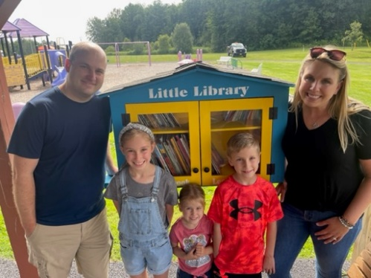
Community Service Events and Activities
It has been a successful year for the Town of Schroeppel Community Service Department. We again received a CNY Arts grant that assisted with our eight-week summer Monday Music in the Park program, a grant from Oswego County Youth Bureau to help ensure our youth soccer, track and tennis programs, our Morning Arts in the Park, and our Family Fun Day; all great fun for our community! Our park and playground continue to be a popular fun spot for both children and adults for sports and fun. Did you join us for the 2024 Total Eclipse Celebration or our First Responder Breakfast? Have you noticed the generous redo of our Lending Library at Farley Park by the Young family? It is beautiful!! We look forward to our many events coming in 2025. Stay tuned to our Facebook page for updates for Winter sledding, Adult Basketball, Music in the Park, Morning Arts in the Park, Youth Soccer, Track & Field, our new Lacrosse introduction camp, Youth and Adult Tennis Lessons, Upcoming Pickleball, Annual Fun Day, as well as Easter, Memorial Day, Halloween holiday celebrations, and much more! Volunteers are always welcome!!

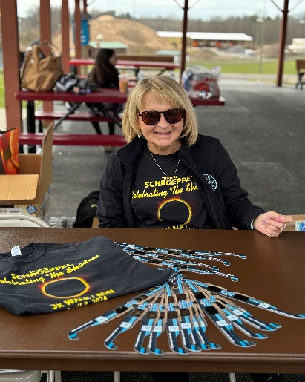

BUILDINGS & GROUNDS
While visiting the Schroeppel Town Hall, you may notice several improvements to our municipal grounds. As you enter the facility, you will notice a new Town of Schroeppel sign displaying our Phoenix Firebird pride with orange and black design. Most noticeable is the Town Hall parking lot. Originally paved in the early 1980’s, the parking lot had deteriorated and became unsafe for our residents. Utilizing capital improvement reserve funds, the Town approved removing the crumbling pavement and repaved the entire parking lot. Entering the hall, you will see streamlined signage above each department window, directional signs and navigational directories making it easier for our residents to find the services they need.
William J. Farley Park Project: The Environmental Protection Fund Parks, Preservation and Heritage Grant Program awarded our Town $500,000 for the design and construction of a community center/pavilion that will begin in the spring/summer of 2025. The recreational facility, including permanent restrooms, will accommodate year-round use, attracting new users and special events to the community park.
Generator: Several years ago, the Town lost its emergency shelter designation because of the poor condition of the Town’s generator. In 2024, the Town received a $50,000 grant from Assemblyman William Barclay for a new generator, once again making the Town hall an emergency shelter for our residents.
Justice Court Assistance Program (JCAP): The Town of Schroeppel Justice Department received $17,885.16 in grant funding for a new metal detector, chairs for the conference room, and windows for the court offices.
Completion of these projects is an investment in the Town’s property and increases the overall value of the Town’s assets. The Town will continue to seek grant funding for future projects for the Town park and Town hall. These projects include a splash pad, dog park, pickleball courts and upgrades to our municipal building.

NEWS FROM THE HIGHWAY SUPERINTENDENT
The Highway Department had a productive 2024. Our projects included paving a portion of Peter Scott Road (1.6 miles), Hoag Road (.36 miles), and Beaver Lane (.18 miles). The Highway Department also contributed to the paving of the Town building parking lot. Road repairs were done townwide along with cross tube cleaning/replacing where needed. A Comprehensive Plan for paving and other various projects is being determined for 2025. Improvements to the Prior Road Bridge are expected to begin in the spring/summer of 2025.

2025 GRANT APPLICATIONS
The New York State Department of Agriculture and Markets Companion Animal Capital Projects Fund: Requested Amount is $150,388 for the renovation of the Town of Schroeppel Dog Shelter for the secure containment, health, and adequate care of sheltered dogs.
Justice Court Assistance Program (JCAP): This year the Justice Court has applied for the 2024-2025 JCAP grant in the amount of $29,937.62 to update the court offices and for new furniture in the judges’ chambers and on the courtroom bench.
The Town of Schroeppel is continually exploring potential grant opportunities through the Consolidated Funding Agency, NY Forward and other sources as this information becomes available.

