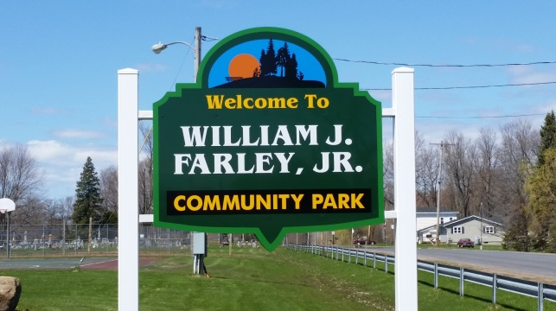 Town of Schroeppel

**Office Use Only:**

Date Paid: ___________________

Amount Paid: ________________

Cash ________ Check# __________

Online Registration ______________

Res __________ Non Res ________

Late Fee ___________________

Additional Notes

______________________________

*Community Services Department*

Parks, Recreation, Community Education, Municipal Projects

69 County Route 57A, Phoenix, NY 13135

Telephone (315) 695-2801

Fax (315) 695-3231

[hknipp@townofschroeppel.com](mailto:hknipp@townofschroeppel.com)



***Youth*:** ***Tuesdays, July 15th – August 12th***

 Star Set (ages 6 – 8) 5 - 6 PM

 Sure Shots (ages 9 – 12) 6 – 7 PM

 Aces (ages 13 – 17) 7 - 8 PM

***\*\*\*Registration Form and payment available online at*** [***www.townofschroeppel.com***](http://www.townofschroeppel.com) ***\*\*\****

***Register by June 30th to secure your place!***

***Youth: $45 Adults: $50***

**\*\*\*Registration D***Registration Deadline June 8th*** 8th\*\*\***

***Adults*:  *Thursdays, July 17th – August 14th***

 Adults (ages 18 and over) 6 – 7 PM

Program Name: **2025** **Tennis Lessons** Today’s Date: __________

Participants Name: _____________________________ Grade: _____ Age: _____

Address: ____________________________________ Date of Birth: __________

____________________________________ Sex: M _____ F _____

Tennis experience: __________________________________________________________________________

**Is the participant a town resident? _______**

**List any medical conditions or other conditions: ______________________________________**

**A written doctor’s release is required if you have asthma or health problems. Are there any**

**physical or health conditions that we need to be aware of? Specify: ____________________**

**(*We cannot guarantee make-ups for weather related cancellations.)***

**Parent / Guardian Information: *(Please list in contact order)***

Name: ________________________________________ Relation: _______________________________

Phone Number: _________________________________ Email: ________________________________

Name: ________________________________________ Relation: _______________________________

Phone Number: _________________________________ Email: ________________________________

**(over)**

**Emergency Contact:**

Name: ______________________________________________ Relation: ____________________________

Phone Number: ______________________________________

Doctor to notify in case of emergency: _____________________________ Phone: __________________

Hospital preference, if any: __________________________________________________________________

 ***CONSENT FOR MEDICAL TREATMENT OF A MINOR***

I understand that there is no accident or injury insurance coverage for injuries incurred in this program.

I agree to be financially responsible for any injuries related to program participation.

I understand that the fees for this program are not refundable except in the case of departmental cancellation.

If the participant named above is a minor:

1. My signature signifies my permission for this person to participate in this program.
2. I give my consent for a licensed physician to perform whatever medical treatment is deemed necessary in my absence.
3. I give permission for the above names participant to be transported to the nearest available medical facility in the event of an injury.

_________________________________________________________ ____________________________

Signature of Parent or Guardian OR Adult Participant Date

 I give my permission for my child to be photographed for publicity purposes.

Signed: ____________________________________________ Date: _______________________

How did you hear about our program? ________________________________________________________

 *Please make checks payable to ***Town of Schroeppel***

Registration forms can be emailed to hknipp@townofschroeppel.com and payment can be made online at [**https://www.govpaynow.com/gps/user/plc/a001i8**](https://www.govpaynow.com/gps/user/plc/a001i8). Or registration forms, along with a check or money order, can be dropped off in the Community Services drop box at the front of the Town of Schroeppel office building.

**Registrations and payment may also be mailed to:**

**Community Services Department**

**Town of Schroeppel**

69 County Route 57A

Phoenix, NY 13135