Town of Schroeppel
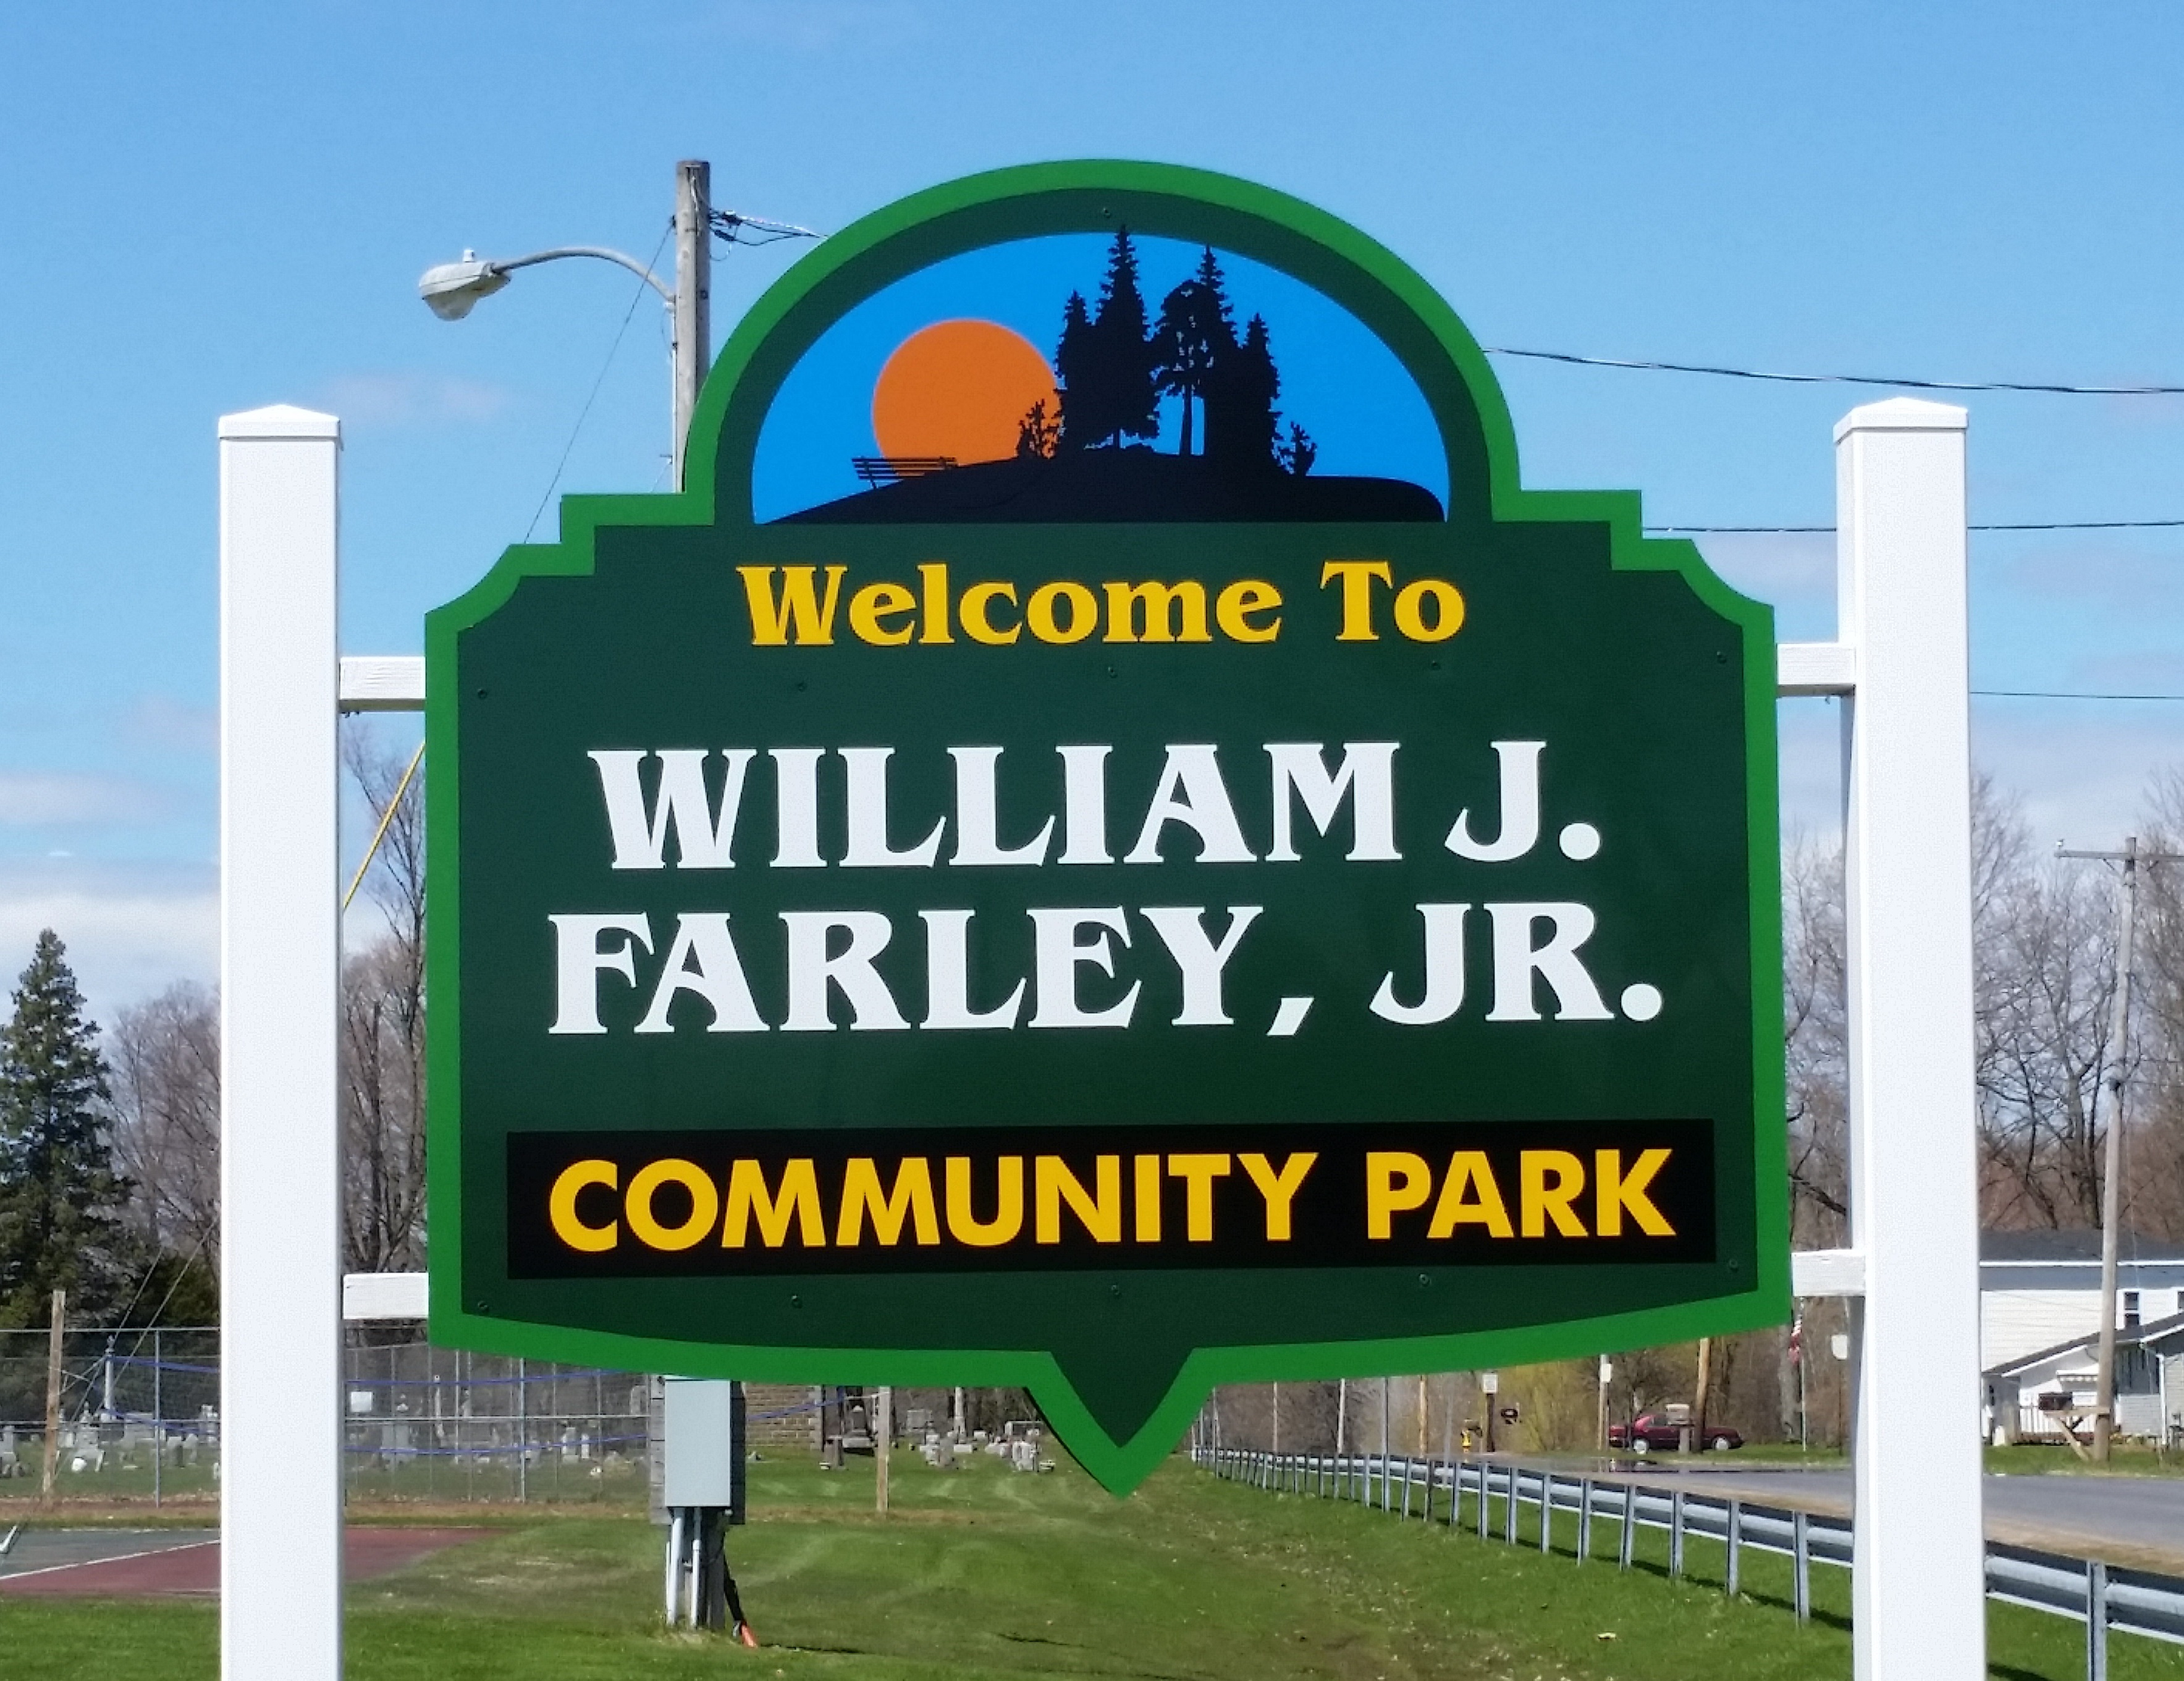
Department of Community Services
69 County Route 57A, Phoenix, NY 13135
Helen Knipp Phone (315) 695-2801 Fax (315) 695-3231 Cary Redhead
Department Coordinator hknipp@townofschroeppel.com Town Supervisor
2022 Summer Program Offerings
Mornings in the Park/Arts and Crafts/Recreation- Join us Mondays-Thursdays, 6/27 – 8/11 at the William J. Farley, Jr. Community Park from 9:30 - Noon for arts and crafts, organized activities or sign out some playground equipment and enjoy your park! Ages 11 and under must be accompanied by an adult. This is a FREE program!
Schroeppel Youth Soccer League- Ages 4 through age 13. Registration is
May 1- June 24. League runs 7/11 – 8/11, Tuesdays and Thursdays. Forms can be downloaded from the web site, or picked up at the Community Services Office. Volunteers needed. Fee: Residents- $40 Non-Res- $45. See registration for early bird discount and 4-year-old My Buddy & Me program information.
Track and Field- Learn the basics of track and field and enjoy some event competition. Ages 5-13, registration begins May 1. Held Mon. and Wed., 7/11 – 8/10 from 6:30 – 8:00 PM. Forms can be downloaded from the web site or picked up at the Community Services Office. This is a FREE program open to the first 25 participants to register! All Participants must be accompanied by an adult. Volunteers needed.
Tennis- Lessons for both youth and adult is pending locating a tennis coach. Please check on our website, Facebook or contact hknipp@townofschroeppel.com for updates
Music in the Park Concert Series –FREE family friendly concerts are held Monday evenings, 7/11 - 8/29, from 6-8PM at Henley Park in downtown Phoenix.
Phoenix Community Fun Day- Mark Sat. Aug 13th, 10:000AM – 1:00 PM, on your calendar and join us up at Farley Park for a day of summer family fun and celebration! Games, prizes, raffle, live entertainment, refreshments and more! Weather permitting. This is a FREE event!
Community Gardens- Residents may reserve a raised bed garden plot for their individual use. Produce from our Community plots is donated to the Phoenix Food Pantry, Senior Nutrition Site and Paddock's Landing. If you are interested in your own plot, donating your time for our community plots or making a donation please contact the Community Services Office. Volunteers needed.
The William J. Farley, Jr. Community Park is home to a large playground area, which includes a playground accessible to children with special needs, a walking track, tennis courts, a basketball court, several ball fields, a soccer/football field, a winter sledding hill, pavilions, and BBQ grills. The park is located on Chestnut Street, just outside the Village of Phoenix and is open from dawn to dusk. In addition to being tobacco free, Farley Park is a carry-in/carry-out park, so please be sure to carry out any trash home with you. Pavilions may be rented for events by downloading the Park Rental Form or contacting the Community Services Office.

If you LIKE our programs be sure to LIKE us on Facebook
and FOLLOW us on Instagram.
Facebook: Town of Schroeppel Department of Community Services
Instagram: townofschroeppelcsd
Visit www.townofschroeppel.com
and click on the Community Services link
to download registration forms for our programs. Online payment only is available!
You can mail the registration or drop off the registrations and/or payment in the Community Service mail slot at the front door of the town building.

