Enhance your life with greater connection and fun memory-making through our community programming! We offer a variety of programs for a wide range of ages, many of which are free to participate in.  Programs happen in different areas around the Town of Schroeppel, but you are always welcome to enjoy our very own William J. Farley, Jr. Community Park. It is home to a large playground area, which includes a playground accessible to children with special needs, a walking track, tennis courts, a basketball court, several ball fields, a soccer/football field, a winter sledding hill, pavilions, and BBQ grills. The park is located on Chestnut Street, just outside the Village of Phoenix and is open from dawn to dusk. In addition to being tobacco free, Farley park is a carry-in/carry-out park, so please be sure to carry out any trash home with you. Pavilions may be rented for events by downloading the Park Rental Form or contacting the Community Services Office. |  |  | Town Supervisor:  Joann Nazarian  Town Board Members:  Tom Millert  Matt Notaro  Justin Hart  Zachary Gelling  Community Services Coordinator:  Helen Knipp |  |  | Town of Schroeppel  Department of Community Services  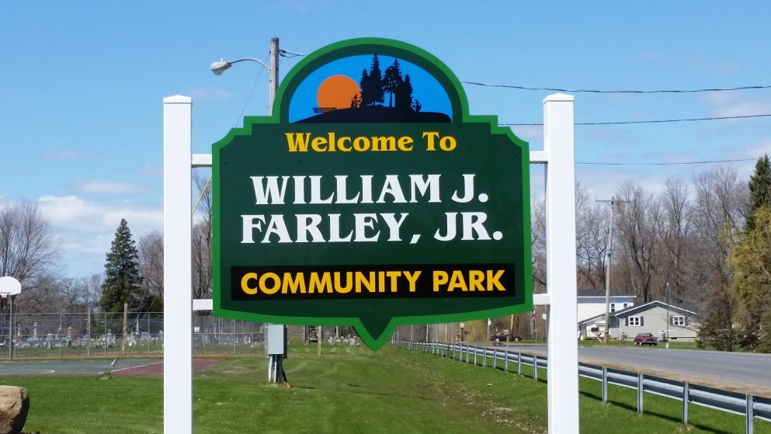  2025  Activity Offerings  69 County Route 57A  Phoenix, NY 13135  (315) 695-2801  www.townofschroeppel.com  hknipp@townofschroeppel.com  2025  Activity Offerings  69 County Route 57A  Phoenix, NY 13135  (315) 695-2801  www.townofschroeppel.com  hknipp@townofschroeppel.com

Mornings in the Park: Arts and Crafts and Equipment Sign Out  Join us Mondays-Thursdays, June 30 – August 14 at the William J. Farley, Jr. Community Park from 9:30am - Noon for arts and crafts. Join in some organized activities or sign out some playground equipment and enjoy your park! Ages 11 and under must be accompanied by an adult. This is a FREE program!  Youth Soccer Leagues:  Summer and Fall sessions are available. These programs are for children age 4 and older. Summer registration closes June 21, 2025. Fall registration closes August 16, 2025. Late fee registration applies. Summer league runs July 14 - August 13. Fall league runs September 8 – October 11. Volunteers needed. Fee: Single session: $50 // Combined session discount: $90 // Please register online: https://leagues.bluesombrero.com/schroeppelsoccer |  |  | Track and Field:  Learn the basics of track and field and enjoy some event competition. Ages 5-13. Register by June 30. Program runs July 15 – August 16. Held Tues. 6:30–8:00pm and Saturdays 10am-12:30pm. Forms can be downloaded from the web site or picked up at the Community Services Office. This is a FREE program! Volunteers needed. All participants must be accompanied by an adult.  Tennis:  Join us at Farley Park for a 5-week program of tennis instruction, skill building, and fitness. Youth and Adult programs available. Fees: $45 for Youth // $50 for Adult. Register by June 30. Youth sessions run Tues. July 15 – August 12. Adult sessions run Thurs. July 17 – August 14. Forms can be downloaded from the web site or picked up at the Community Services Office. |  |  | Music in the Park Concert Series:  Shows are held Monday and Friday evenings, June 30 – August 29, from 6-8pm at Henley Park in downtown Phoenix. This project is made possible through the CNY Arts Grants for Regional Arts and Cultural Engagement regrant program thanks to a New York State Senate Initiative supported by the NYS Legislature, the Office of the Governor, and administered by the New York State council on the Arts. We are also thankful to the local businesses and individuals who donate to support this project. This is a FREE program!  Phoenix Community Fun Day:  Mark Saturday August 2, 10:00am - 1:00pm, on your calendar and join us up at Farley Park for a day of summer family fun and celebration! Lots of activities will be available, including free prizes for every child, a free children’s bike raffle, adult raffles, games, live entertainment, refreshments and more! Come out for some great community fun and enjoy an afternoon in the park! Weather permitting. This is a FREE event!

